
U S E R M A N U A L
YADA
Yet Another Delivery App

On-demand motor courier dispatch for businesses and riders.
Covers the business workspace and the courier workspace.
DOCUMENT | YADA User Manual
VERSION | 1.0
DATE | August 2026
APPLIES TO | YADA web application, first release
AUDIENCE | Business account holders and motor couriers
© 2026 YAST — Yet Another Software Team. Documentation released under CC BY 4.0.

Contents

1 About this manual 4
1.1 Who this manual is for 4
1.2 How this manual is organised 4
1.3 Conventions used in this manual 5
1.4 What YADA does and does not do 5
2 Getting started 7
2.1 What you need 7
2.2 The two workspaces 7
2.3 Creating a business account 8
2.4 Creating a courier account 9
2.5 Signing up with Google 10
2.6 Verifying your email address 10
2.7 Signing in and signing out 10
2.8 Resetting a forgotten password 10
3 The business workspace 12
3.1 The dashboard 12
3.2 Setting your dispatch address 13
3.3 Sending a delivery request 13
3.4 Tracking a delivery 14
3.4.1 Finding a rider 14
3.4.2 A rider is on the way 15
3.4.3 Confirming the handover 15
3.4.4 On the road 15
3.4.5 Delivered, and rating the rider 16
3.5 Cancelling a delivery 17
3.6 When no rider is found 17
3.7 Running several deliveries at once 17
3.8 History 18
3.9 Your account and profile 18
4 The courier workspace 20
4.1 Getting around 20
4.2 Going online 20
4.3 Answering a request 21
4.4 The Orders screen 22
4.5 Collecting the parcel 23
4.6 Delivering 23
4.7 Finishing, and rating the business 24
4.8 Taking a second delivery on the back of the first 24
4.9 Trips 25
4.10 Settings 26
5 How dispatch works 28
5.1 The search widens on its own 28
5.2 Who hears about a delivery first 28
5.3 A decline is remembered 29
5.4 When two riders accept at once 29
6 Reference 30
6.1 Delivery statuses 30
6.2 Ratings 30
6.3 Distances and timings 31
7 Privacy, safety and your data 32
7.1 What each side can see 32
7.2 Location reporting 32
7.3 Closing your account 33
8 Troubleshooting 34
9 Glossary 36

1 About this manual
YADA — Yet Another Delivery App — is a web application for on-demand motor courier dispatch. A business raises a delivery request, YADA rings the riders nearest to it until one accepts, and both sides watch the trip through to completion. It replaces the phone calls and text messages that delivery coordination normally runs on.
This manual explains how to use the application. It is written for the people who use YADA every day rather than for the people who build it, and it assumes no technical knowledge beyond being able to open a web browser.

1.1 Who this manual is for
There are exactly two kinds of account in YADA, and this manual covers both.
- Businesses — shops, kitchens, pharmacies and anyone else who needs parcels taken from their counter to a customer. Chapter 3 is the business workspace.
- Couriers — motor riders who accept delivery jobs and carry them out. Chapter 4 is the courier workspace.
There is no administrator account and no supervisor view. Everything a person can do in YADA, they do for their own account or for a delivery they are personally on.

1.2 How this manual is organised
Table 1. Chapter guide.
CHAPTER | WHAT IT COVERS
1 About this manual | Audience, conventions and the scope of the product.
2 Getting started | What you need, creating an account, signing in, email verification and password recovery.
3 The business workspace | The dashboard, sending a delivery, tracking it, cancelling, history and your profile.
4 The courier workspace | Going online, answering requests, pickup, delivery, completion, trips and settings.
5 How dispatch works | How YADA chooses which riders to ring, and in what order.
6 Reference | Delivery statuses, ratings, and the distances and timings the system uses.
7 Privacy, safety and your data | What each side can see, location reporting and closing your account.
8 Troubleshooting | Common problems and what to do about them.
9 Glossary | The terms used throughout this manual.

1.3 Conventions used in this manual
Table 2. Typographic and callout conventions.
CONVENTION | MEANING
Bold text | The name of a button, a field, a tab or a screen exactly as it appears in the application — for example, tap Accept.
Screen → Section | A path through the interface. Settings → Theme means open Settings, then open the Theme row.
NOTE | Extra information that is useful but not essential to completing the task.
TIP | A shortcut or a piece of practical advice.
IMPORTANT | Something that will cost you a delivery, or someone else's time, if you get it wrong.

Screenshots of the business workspace are taken on a desktop browser, and screenshots of the courier workspace are taken on a phone, because that is how each side is used in practice. Both workspaces work on both, and the layout adapts to the screen.
NOTE Sample names, addresses, order values and ratings in the screenshots are illustrative. Your own screens will show your own data.

1.4 What YADA does and does not do
YADA is a dispatch and tracking tool. Specifically, it does the following.
- Raises a delivery request from a business and finds a nearby rider for it, automatically.
- Tracks the rider's position and the stage of the trip, live, on both sides.
- Records what was delivered, by whom, when, and how long it took.
- Collects a rating from each side after the trip.
It deliberately does none of the following.
- It does not price deliveries. No fee is calculated, quoted or displayed anywhere.
- It does not take payment or settle anything. Whatever the business and the rider agree between them happens outside YADA.
- It does not tell the rider what the order is worth. The order value is recorded so a disputed handover has a number attached to it; it is never shown on a courier's screen.
IMPORTANT YADA does not handle money. Any arrangement about payment for a delivery is between the business and the rider, and nothing about it is recorded, enforced or guaranteed by the application.

2 Getting started

2.1 What you need
Table 3. What you need before you start.
REQUIREMENT | DETAIL
A device | Any phone, tablet or computer with a modern web browser. Riders will want a phone; businesses usually prefer a laptop or a tablet on the counter.
A browser | A current version of Chrome, Edge, Firefox or Safari. YADA is a website — there is nothing to install from an app store.
An internet connection | Required throughout. Position updates, offers and status changes all travel over the network.
Location access | Required for couriers, and requested by the browser the first time you go online. Businesses do not need it.
An email address | Used to sign in, to verify the account and to recover a forgotten password.
A phone number | Required for both roles. It is how the other side of a delivery reaches you while it is in progress.

TIP On a phone, open YADA in the browser and add it to your home screen. It then opens full-screen with its own icon and behaves like an installed app.

2.2 The two workspaces
YADA is one application with two entirely separate workspaces. Which one you see is decided by the role you chose when you signed up, and it cannot be switched afterwards. A business account always lands on the business dashboard; a courier account always lands on the courier home screen. There is no screen where the two mix.
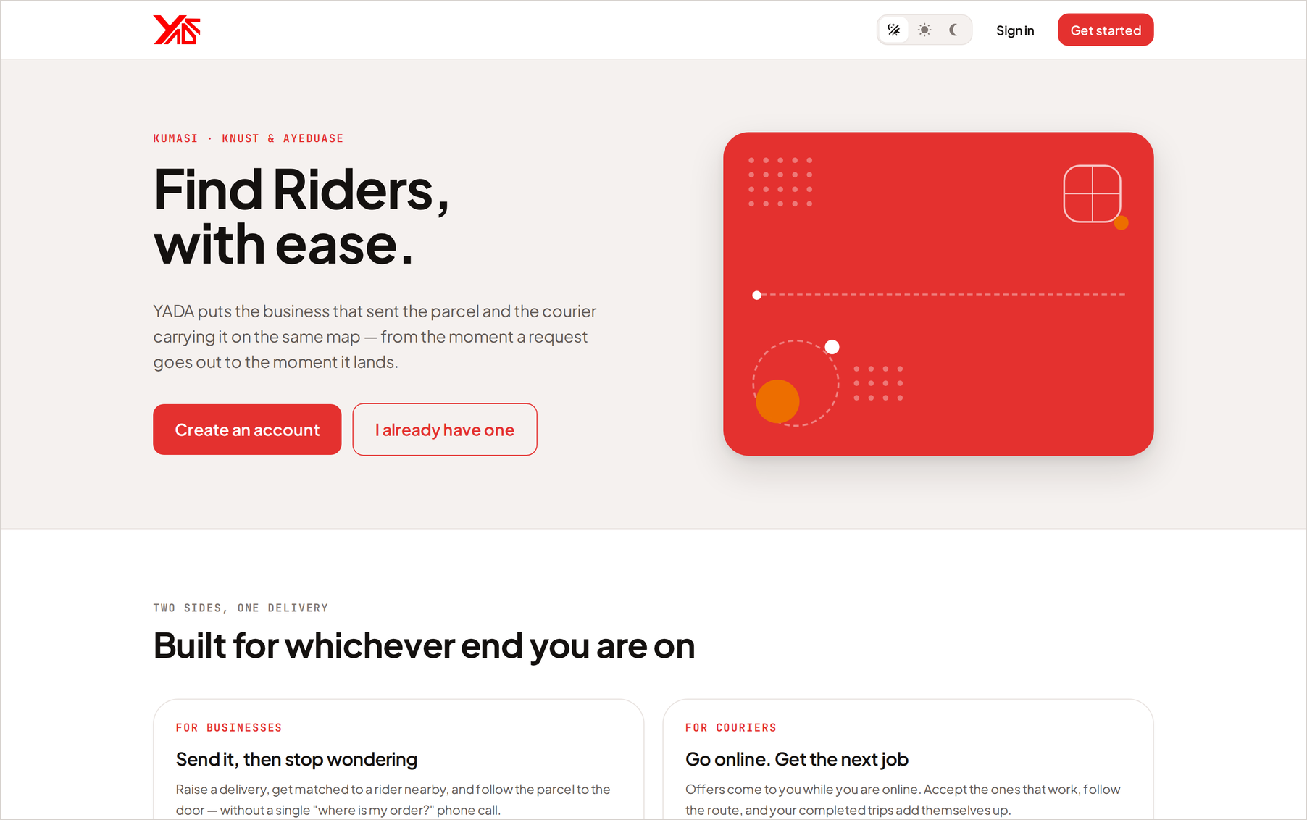
Figure 1. The YADA landing page. Get started leads to sign-up and sign-in.
IMPORTANT Choose your role carefully at sign-up. The role is set once, on the server, and there is no setting anywhere that changes it later. If you pick the wrong one, close the account and sign up again with the correct role.

2.3 Creating a business account
From the landing page, choose Get started, then select the Sign up tab.
- Choose Business on the role toggle at the top of the form.
- Enter your Business Name. This is the trading name riders will see when they are offered your delivery, so use the name on your sign rather than a registered company name.
- Enter your Work email. This becomes your sign-in name and the address verification and password resets are sent to.
- Enter your Phone number. Riders use this to reach you about a pickup in progress.
- Choose a Password of at least 8 characters.
- Select Create account.
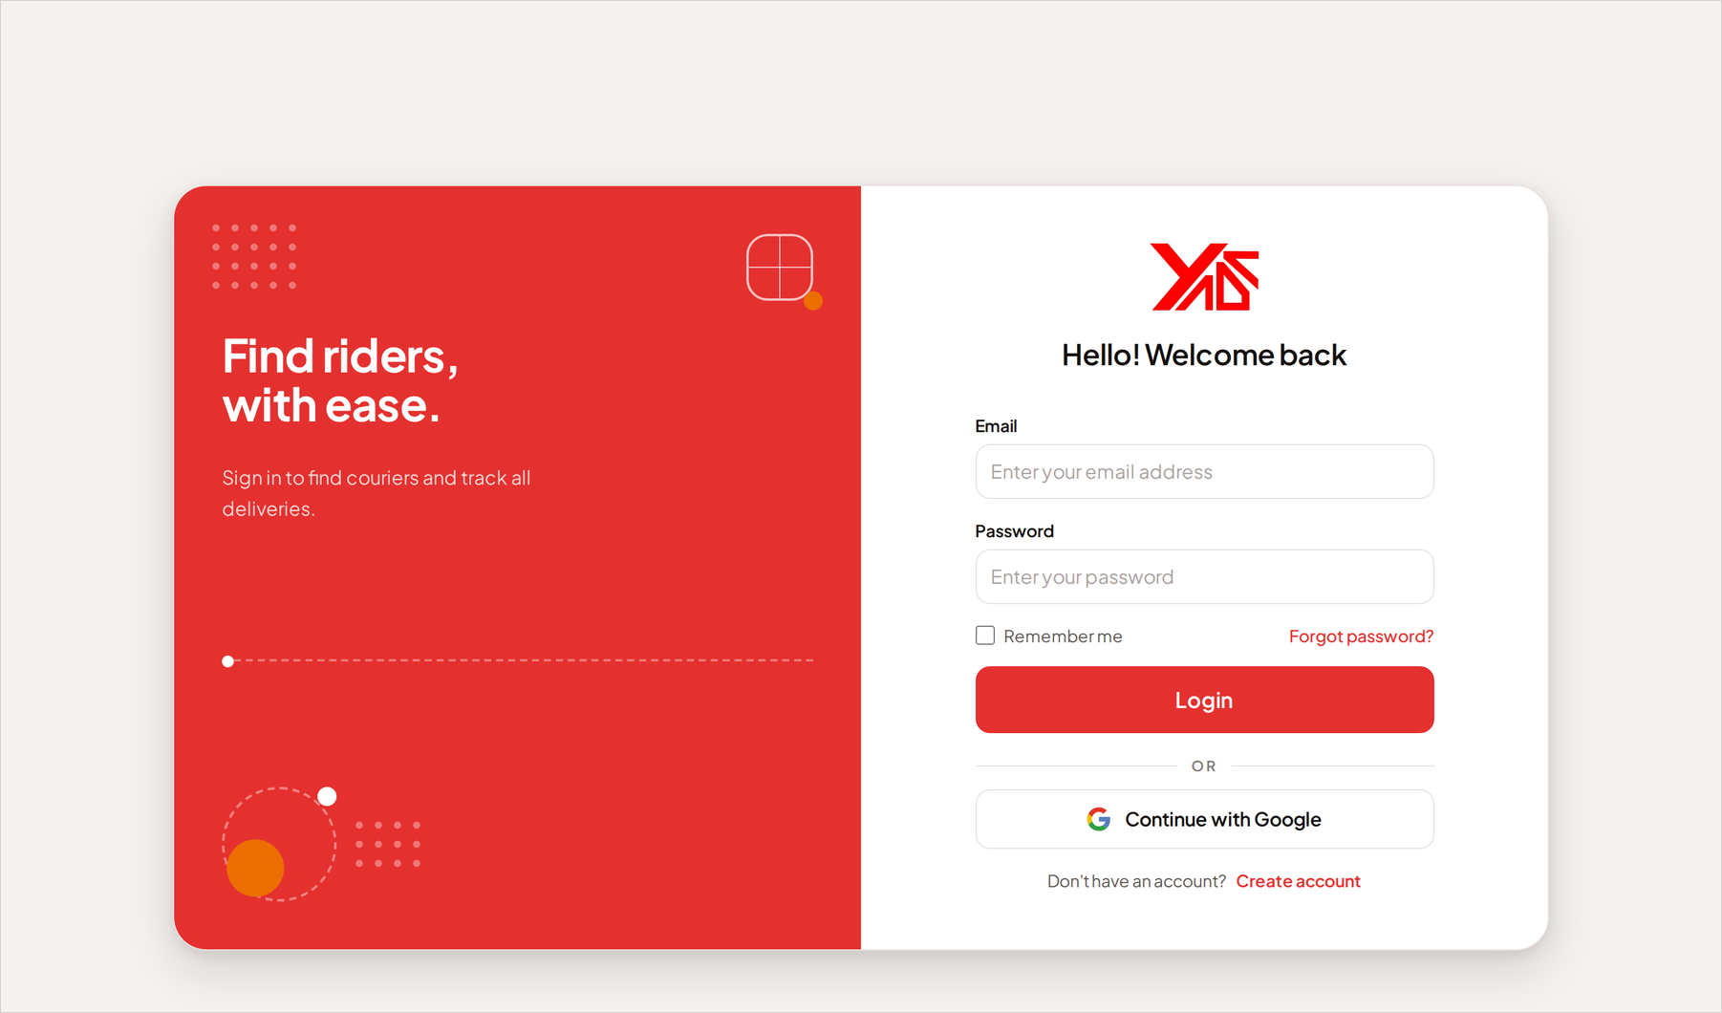
Figure 2. The sign-in and sign-up screen, with the Business and Courier role toggle.
You are taken straight to your dashboard. Before you can send your first delivery you will be asked to set your dispatch address — the counter every delivery leaves from. That is described in section 3.2.

2.4 Creating a courier account
Courier sign-up asks for two things a business is not asked for, so it runs in two steps.
Step 1 — your details
- Choose Courier on the role toggle.
- Enter your Full Name, Email, Phone number and a Password of at least 8 characters.
- Select Continue.
Step 2 — your bike and your photo
- Enter your Number plate, for example GT 4521-20. The business sees this while they wait, so they know which bike at the counter is yours.
- Add a Profile photo. The business sees this the moment you accept their delivery, so they know who to hand the parcel to. Choose a clear photo of your face.
- Select Create account.
NOTE Your photo is resized in your own browser before it is sent, to roughly the size of an avatar. The full-resolution original never leaves your device.

2.5 Signing up with Google
Where Google sign-in is enabled, Continue with Google creates an account from your Google profile. Google supplies your name, your email address and often a picture; it cannot supply a phone number, a number plate, or which workspace you came for. YADA therefore shows a short Almost there screen after the redirect, which asks for whatever is missing:
- The role — Business or Courier — if the button you used did not already carry it.
- Your phone number.
- For couriers, the number plate and a profile photo. If Google supplied a picture, Use this photo adopts it in one tap.
You cannot reach either workspace until this screen is complete. It is asked once.

2.6 Verifying your email address
After sign-up, YADA emails you a verification link. Verification is a soft gate: it never stops you signing in, and it never stops you looking around your own workspace. It gates exactly the two actions that reach another person.
Table 4. What email verification gates.
ROLE | BLOCKED UNTIL YOU VERIFY
Business | Sending a delivery request.
Courier | Going online to receive requests.

Open the message and select the link. If it has not arrived, check the spam folder first, then use the resend option on the banner in your workspace.

2.7 Signing in and signing out
Go to the YADA address, select Sign in, and enter your email and password. YADA remembers the session, so on your own device you will usually not have to sign in again.
- Business — open the account menu from the avatar at the top right of any screen, then choose Sign out.
- Courier — open Settings from the tab bar and select Sign out at the bottom.

2.8 Resetting a forgotten password
- On the sign-in screen, select Forgot password.
- Enter the email address on the account and submit.
- Open the email you receive and select the link.
- Enter a new password of at least 8 characters and confirm it.
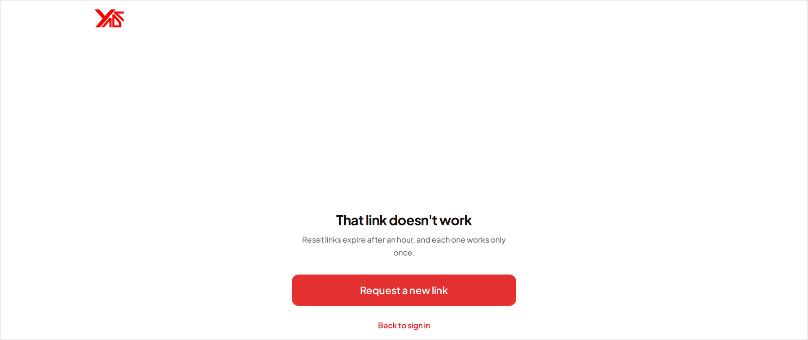
Figure 3. Setting a new password from a reset link.
NOTE Reset links are single-use and expire. If yours has stopped working, the screen will say so — request another one from the sign-in page.

3 The business workspace
The business workspace has three destinations, named across the top of every screen: Dashboard, Request and History. Your account and your settings are behind the avatar at the top right.

3.1 The dashboard
The dashboard is the board of everything happening right now. It opens on three figures for the day, followed by the list of deliveries that are still running.
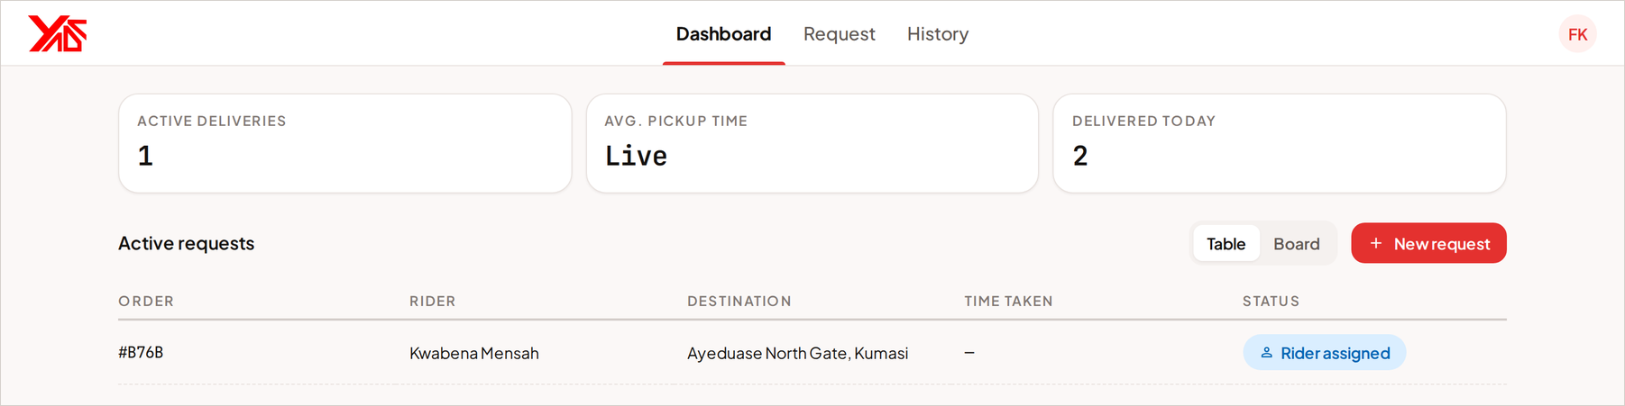
Figure 4. The dashboard, with the day's summary figures above the list of active requests.
Table 5. The business dashboard at a glance.
ELEMENT | WHAT IT TELLS YOU
Active deliveries | How many of your deliveries are in flight right now — searching for a rider, or already assigned to one.
Avg. pickup time | How long, on average, riders have taken to reach your counter today.
Delivered today | Deliveries completed since midnight.
Active requests | One row, or one card, per delivery in flight: the order, the rider, the destination, the time taken so far and the current status.
Table / Board | Switches the active requests between a compact table and a card board. Both show the same deliveries.
New request | Starts a new delivery request. Same destination as the Request tab.

Selecting any active request opens a panel with its destination, its rider, the pickup time and the order details, and a map of where the rider is. Open tracking takes you to the full tracking screen for that delivery.

3.2 Setting your dispatch address
Every delivery you send leaves from one place: your dispatch address. YADA asks for it the first time you open Request, and you can change it later under the avatar menu, in Account → Dispatch address.
- Search for the address, or tap the map to drop a pin on your entrance.
- Check the name YADA gives the pin. Dropped pins are named against local landmarks, so the result reads like a place in Kumasi rather than a pair of coordinates.
- Save it.
IMPORTANT A delivery request cannot nominate its own pickup point. Every request you send starts at this address, so put the pin where a rider should actually stop — the entrance customers use, not the middle of the building.

3.3 Sending a delivery request
Open Request. The pickup is filled in for you; the rest of the screen is about where the parcel is going and what is in it.
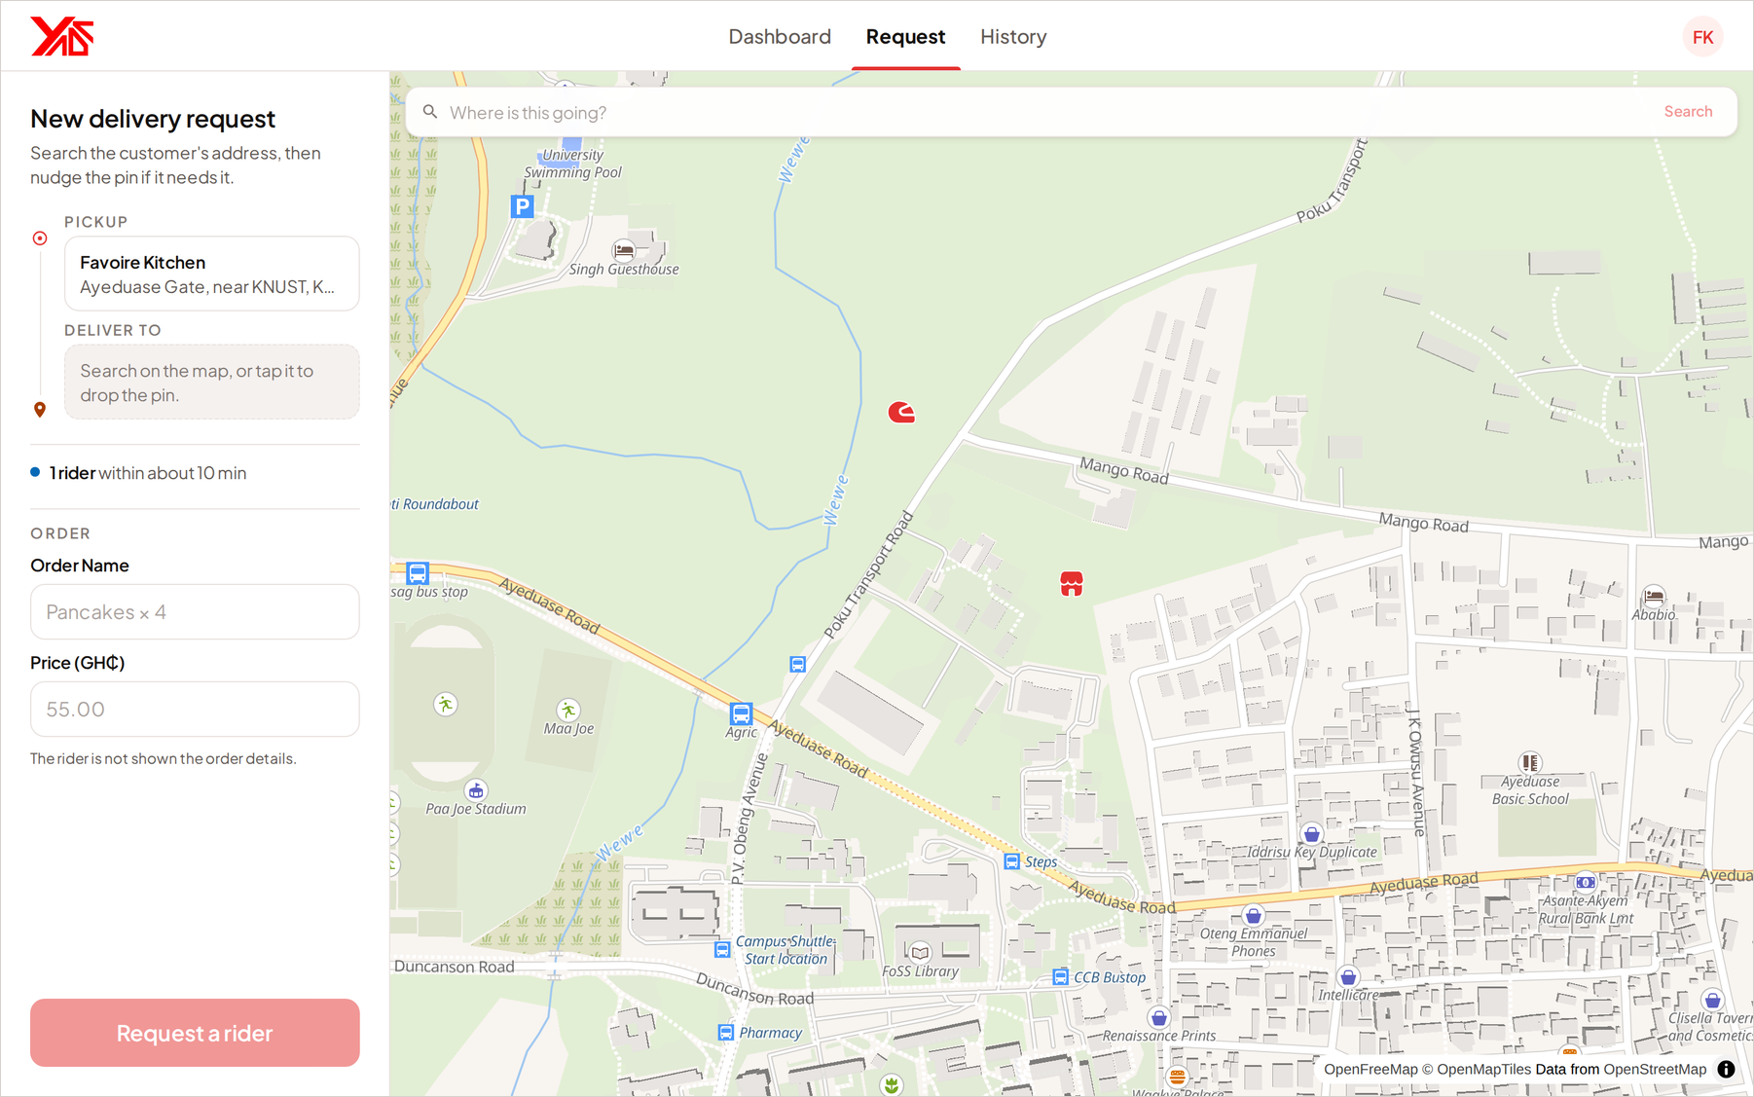
Figure 5. The new delivery request screen. The pickup is fixed; the destination is searched or dropped on the map.
- Set the destination. Type the customer's address into Where is this going? and pick a prediction, or tap the map to drop a pin. You can nudge the pin afterwards if the search put it slightly off.
- Enter the Order Name — what is actually being sent, for example “Pancakes × 4”. This is what the delivery is called everywhere afterwards, including in your history.
- Enter the Price (GH₵) — what the order is worth. This is a record, not a delivery fee, and the rider is never shown it.
- Check the rider count above the order fields. It tells you how many riders are online within about ten minutes of your counter, before you commit to anything.
- Select Request a rider.
As soon as both points are set, YADA works out the distance and the driving time between them and stores that estimate with the trip. That is what lets the dashboard show an ETA before the rider has sent a single position.
NOTE The riders drawn on the map before you book are anonymous by design. There are no names, no ratings and no identities on those markers, and the positions are rounded. The map is showing you supply, not people.

3.4 Tracking a delivery
Sending a request takes you straight to its tracking screen. Every delivery has its own — you can return to it at any time from the dashboard.

3.4.1 Finding a rider
The request now rings riders. The map shows the search widening out from your counter, and the bar beneath Finding a rider near you drains as the search window runs down. The whole search lasts 60 seconds. Chapter 5 explains what is happening underneath.
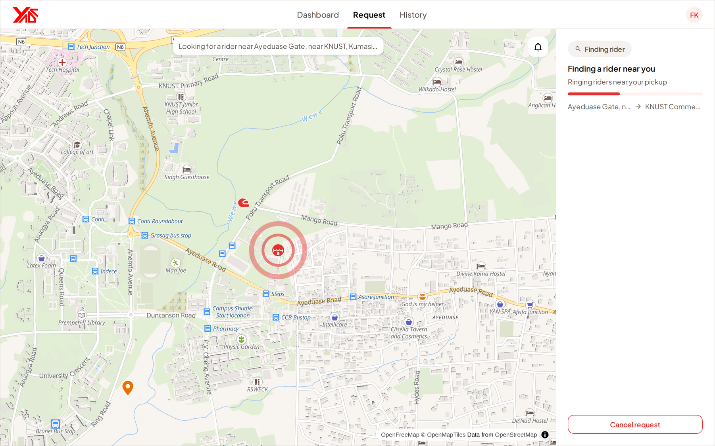
Figure 6. A request searching for a rider. The rings on the map widen as the search does.
While the search is running you can Cancel request at any time.

3.4.2 A rider is on the way
When a rider accepts, the screen changes to show who they are: their name, their photo, their rating and their number plate, with a call button beside them. The map switches to their live position, moving towards your counter, with an ETA.
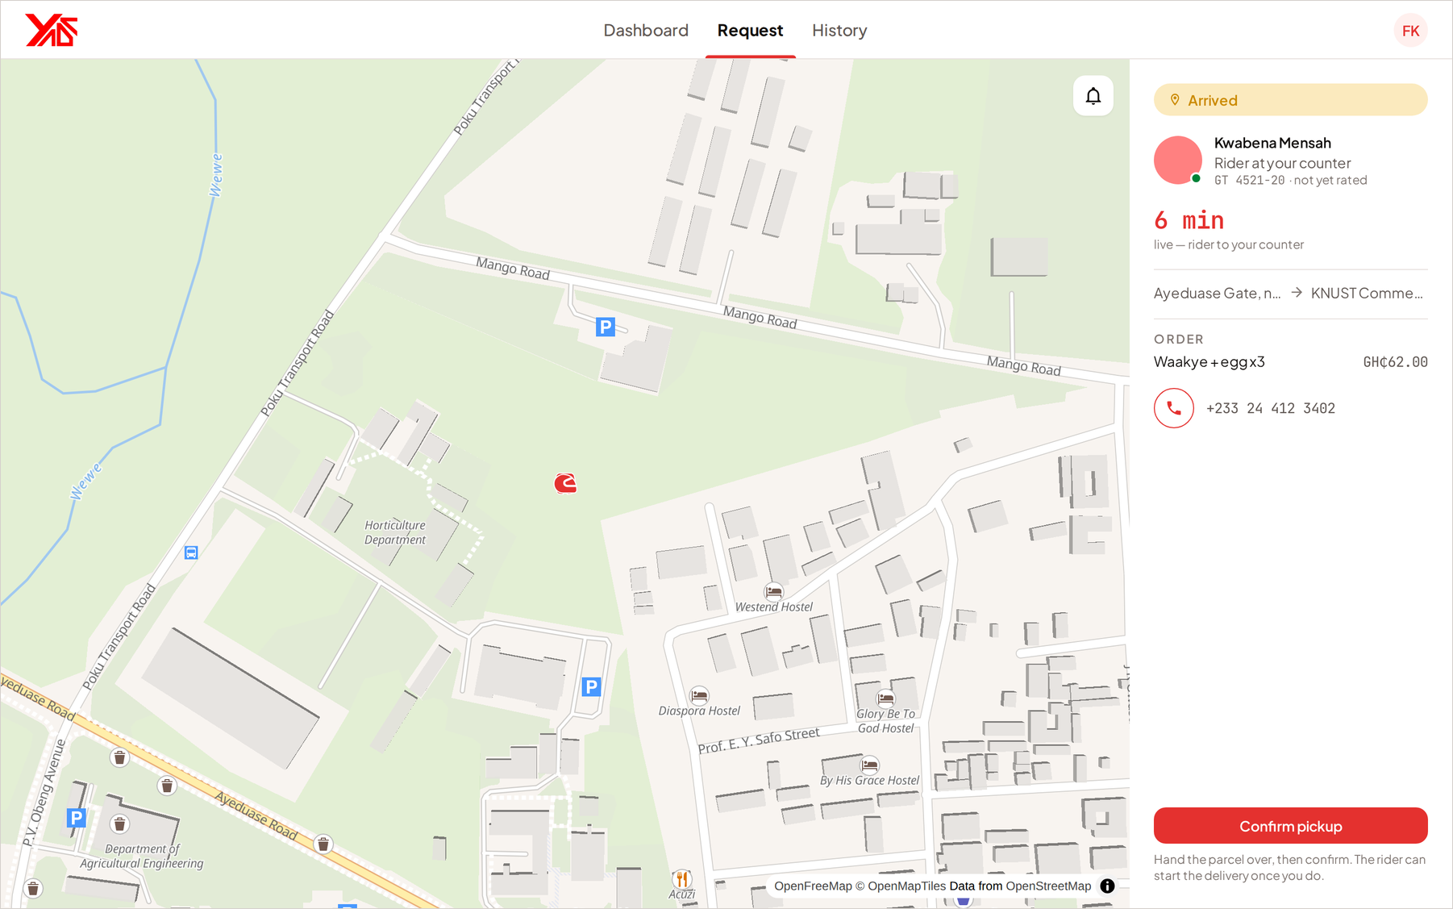
Figure 7. A rider assigned and on the way to the pickup.

3.4.3 Confirming the handover
The pickup phase ends with you, not with the rider. When the rider's own position shows them at your counter, a Confirm pickup button appears on the tracking screen. Hand the parcel over, then confirm. The rider cannot start the delivery until you do.
IMPORTANT Confirm pickup only after the parcel is physically in the rider's hands. The confirmation is what starts the delivery leg and what the record of the handover rests on. The button appears only when the rider is at your counter, so it cannot be pressed from the road.

3.4.4 On the road
Once you have confirmed, the trip moves to the delivery leg. The map follows the rider towards the customer and the ETA updates as they go.
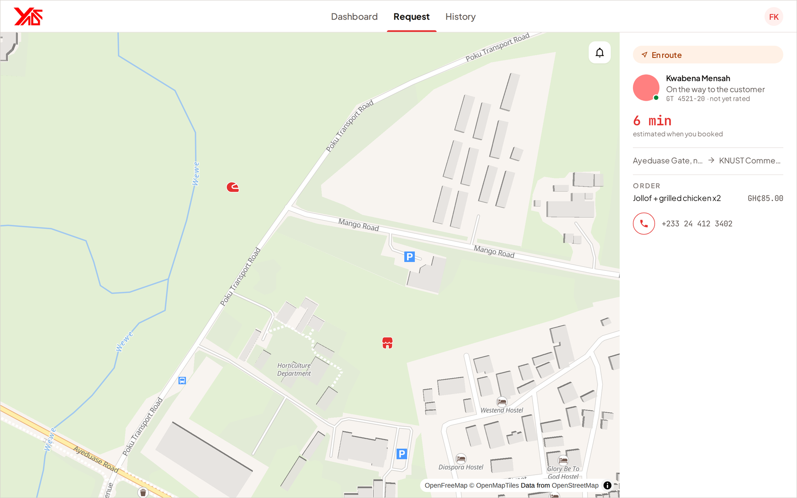
Figure 8. A delivery in progress, tracked to the drop-off.

3.4.5 Delivered, and rating the rider
The rider marks the delivery complete at the drop-off, and your screen turns over to a summary: the order, the rider, and when it was delivered. Beneath it you are asked to rate the rider from one to five stars, with an optional note.
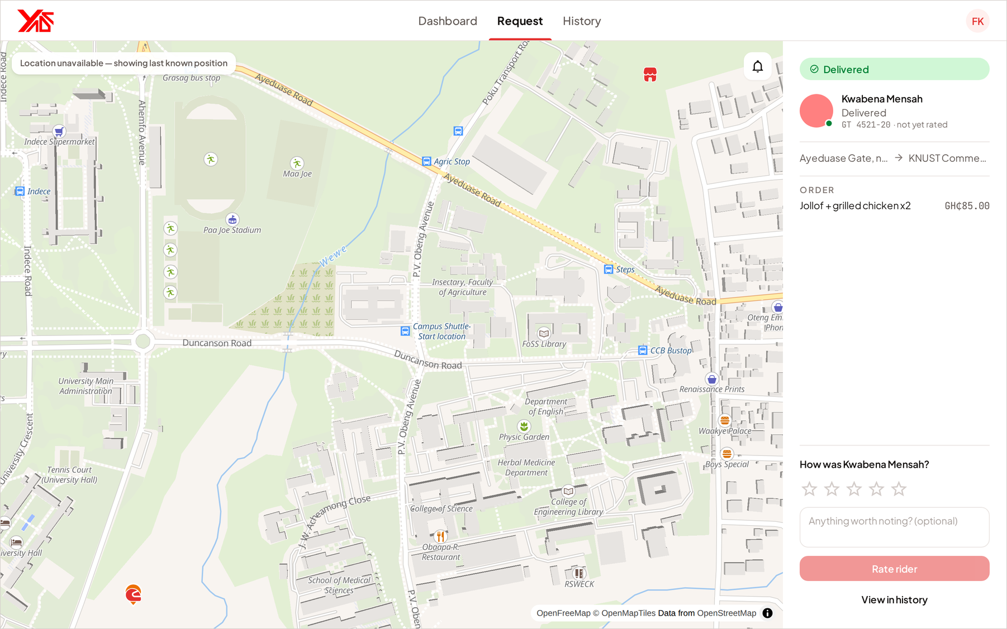
Figure 9. The completed delivery, with the rating prompt.
Ratings feed the dispatcher. A rider's rating is one of the things that decides how early they hear about your next request, so rating honestly is worth the ten seconds it takes. If you skip it now, you can still rate the delivery later from History.

3.5 Cancelling a delivery
Either side can call a delivery off, but only up to a point.
Table 6. When a business can cancel.
STAGE | CAN YOU CANCEL?
Searching for a rider | Yes — Cancel request on the tracking screen.
A rider has accepted and is on the way | Yes — Cancel delivery on the tracking screen.
The rider has reached your counter | No. The button is gone.
The parcel has been handed over | No.

The cancel button disappears the moment the rider arrives, and that is deliberate. Someone is then standing at your counter for this delivery, and calling it off at that point is a conversation rather than a button. Talk to the rider.

3.6 When no rider is found
If the 60-second search ends with nobody accepting, the request does not disappear — it comes back to you. The tracking screen offers two things:
- Ring riders again — starts a fresh search for the same request. Riders who already declined this delivery are not asked a second time.
- Cancel request — withdraws it.
TIP If a search fails twice in a row, there is probably nobody online near you at that moment. The rider count on the Request screen tells you before you spend another minute on it.

3.7 Running several deliveries at once
YADA is built for a counter with several orders leaving in the same few minutes. You can have as many deliveries in flight as you have orders.
- Each request runs its own search, on its own clock, with its own set of riders.
- Two requests raised seconds apart do not queue behind one another.
- Each has its own tracking screen, and all of them appear together on the dashboard.
There is nothing to configure for this. Send the second request the same way you sent the first.

3.8 History
History is the record of every delivery you have completed or cancelled. Filter it by Status, or search by order name to find one delivery.
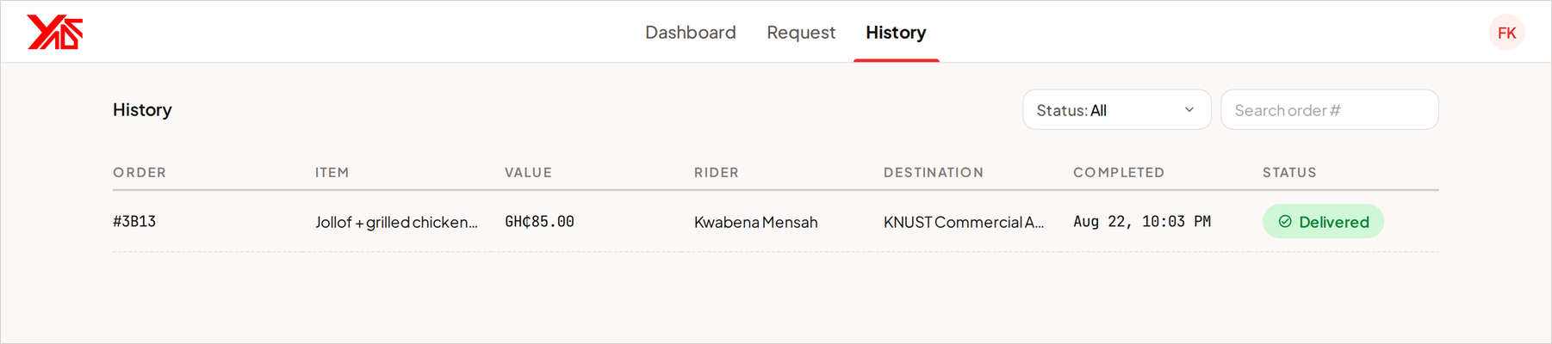
Figure 10. Delivery history, filterable by status and searchable by order.
Selecting a row opens the full record: the order and its value, the destination, the pickup, the rider, when it was completed and any notes. If you have not yet rated the rider on that delivery, you can do it from here.

3.9 Your account and profile
Open the avatar at the top right, then Account. Everything about your business lives on one screen.
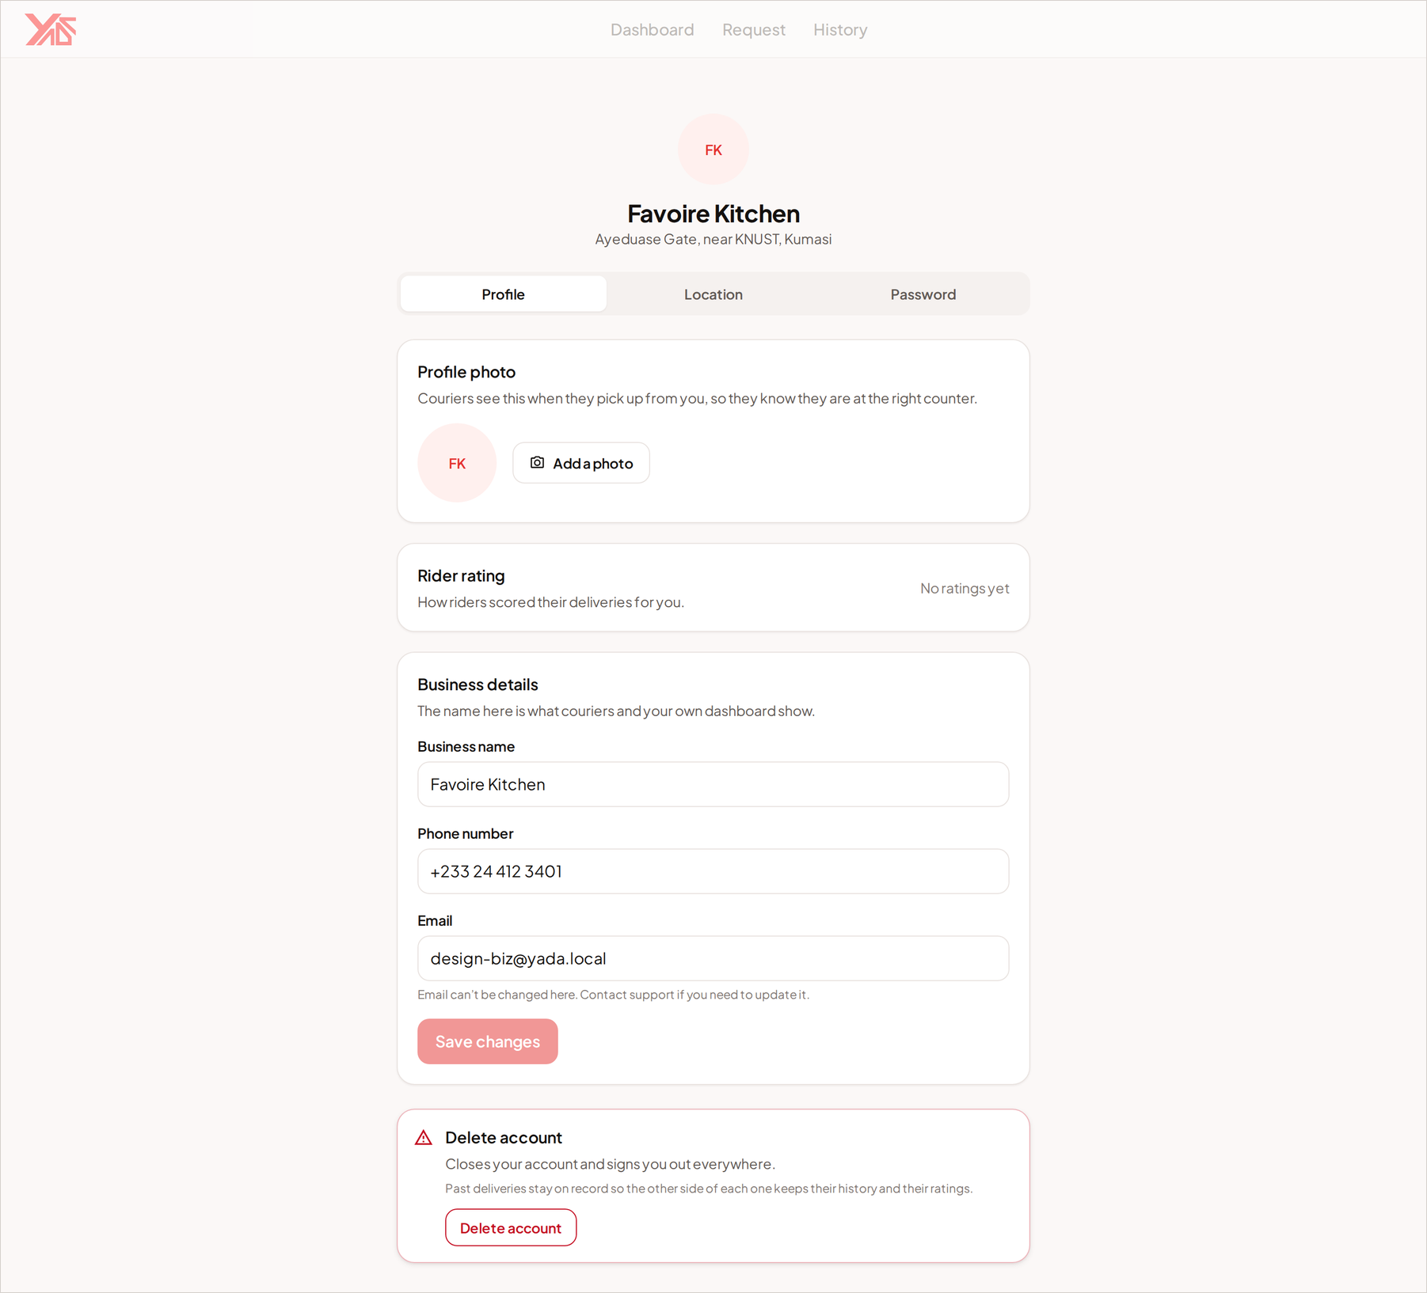
Figure 11. The business account screen.
Table 7. The business account screen.
SECTION | WHAT YOU CAN DO
Profile photo | Upload or remove the picture riders see when they are offered your delivery.
Rider rating | The average rating riders have given you. It is informational — it does not affect how quickly your requests are answered.
Business details | Change your trading name and phone number. The email address is fixed and shown read-only.
Dispatch address | Move the counter every delivery leaves from. See section 3.2.
Change password | Enter your current password, then the new one twice.
Delete account | Closes the account permanently. See section 7.3.

4 The courier workspace
The courier workspace is built to be used one-handed, on a phone, next to a bike. The controls are large, the screens are shallow, and everything you need is one tap from the bar at the bottom.

4.1 Getting around
Table 8. The four courier tabs.
TAB | WHAT IS THERE
Home | The map, your online switch, and any request being offered to you right now.
Orders | Requests waiting for an answer, and the delivery you are currently on.
Trips | Your completed trips, with your totals and your rating.
Settings | Your account, alerts, theme, language and the legal pages.

NOTE While you are on a delivery, the pickup and delivery screens take over the whole display and the tab bar goes away. That is intentional: there is one thing to do, and it is on the screen.

4.2 Going online
You receive no requests until you go online. Open Home and select Go online. Your browser will ask permission to use your location the first time; you must allow it, because dispatch cannot rank you without knowing where you are.
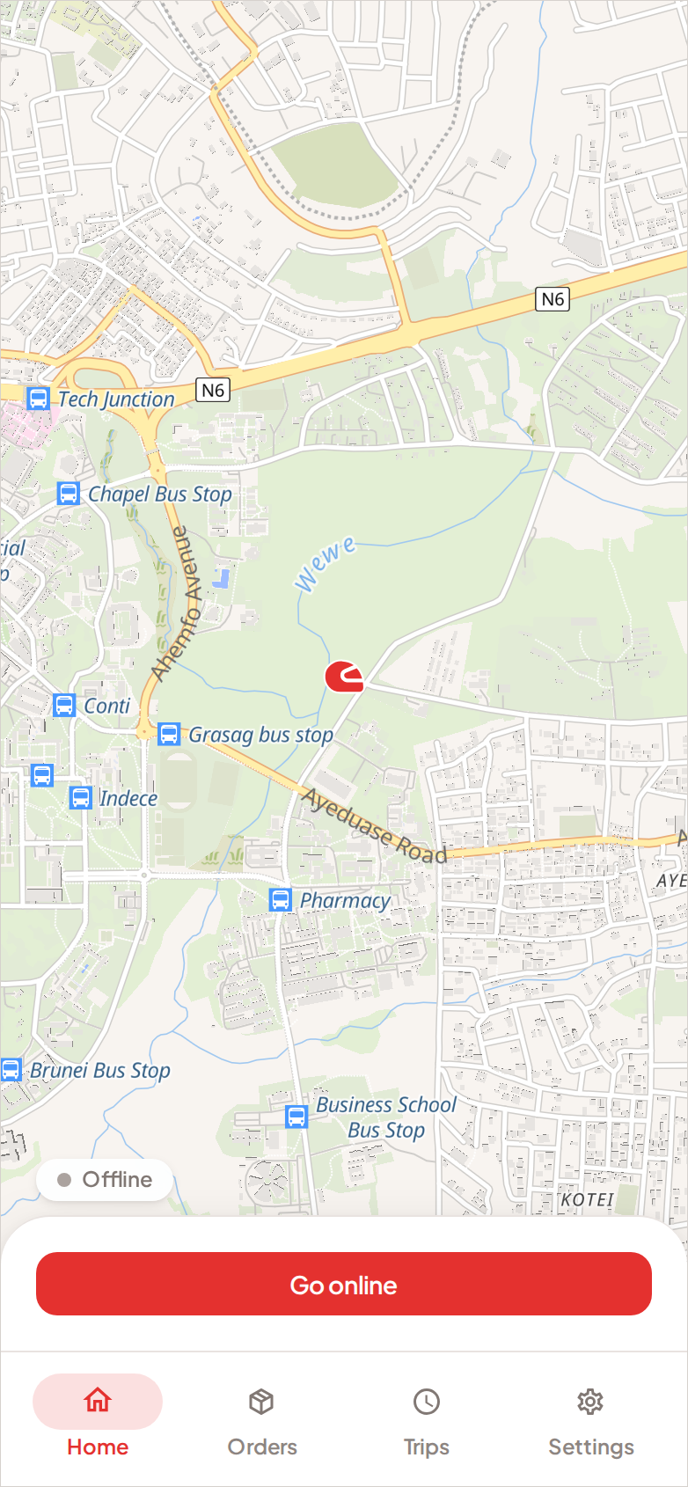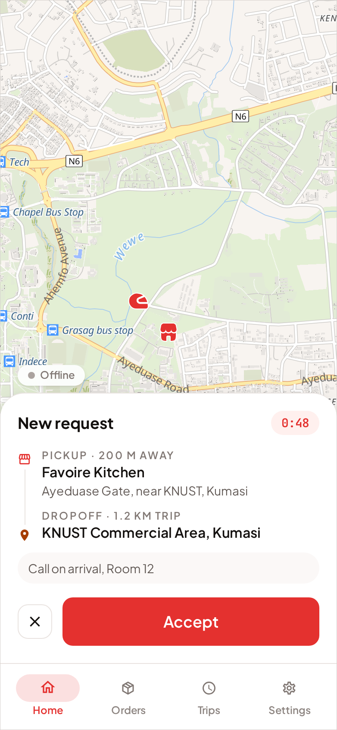
Figure 12. Left: Home while offline. Right: a request being offered, with the timer at the top right and the distance to the pickup.

The pill on the map shows your state — Offline or Online. Go offline stops requests and stops your position being reported. Home also shows what you have done today.
IMPORTANT Your email address must be verified before you can go online. Until it is, the switch will tell you so. Verification is a single link in the email YADA sent you when you signed up.

4.3 Answering a request
When a delivery is offered to you, a card rises from the bottom of Home and the alert sounds. The card tells you everything you need to decide:
- Pickup — the business, its address, and how far away it is. This is the distance the dispatcher actually ranked you by.
- Dropoff — where the parcel is going, and the length of the trip.
- Any note the business added to the request.
- A countdown in the top right, showing how long the offer stands.
Two controls: Accept, and the ✕ beside it to decline.
Table 9. Answering an offer.
ACTION | WHAT HAPPENS
Accept | The job is yours. YADA takes you to the pickup screen and tells the business who is coming.
✕ (decline) | The offer disappears and YADA moves on. You will not be offered this same delivery again, even if the business rings riders a second time.
Let the timer run out | The same as declining, except quieter. The offer closes on its own.

NOTE Several riders are rung for the same request at once, so it is normal for an offer to be taken by somebody else while it is on your screen. If that happens you will be told the job has gone. Nothing has gone wrong, and it counts against you in no way at all.

4.4 The Orders screen
Orders shows requests waiting for an answer under Incoming requests, and the delivery you are currently on above them. If you are offline, or nothing is waiting, it says so and points you back to Home.
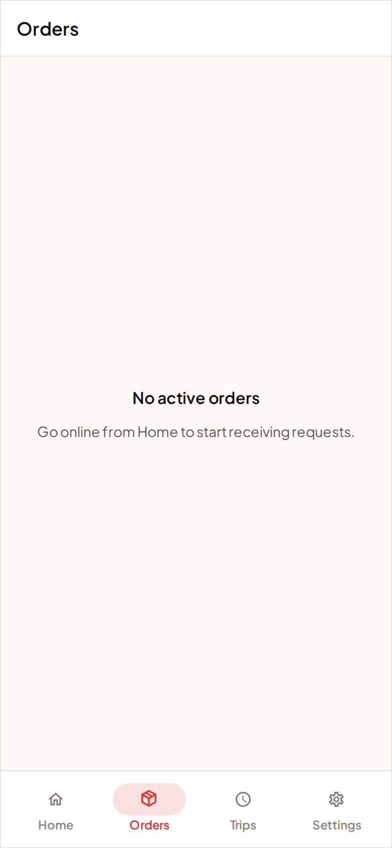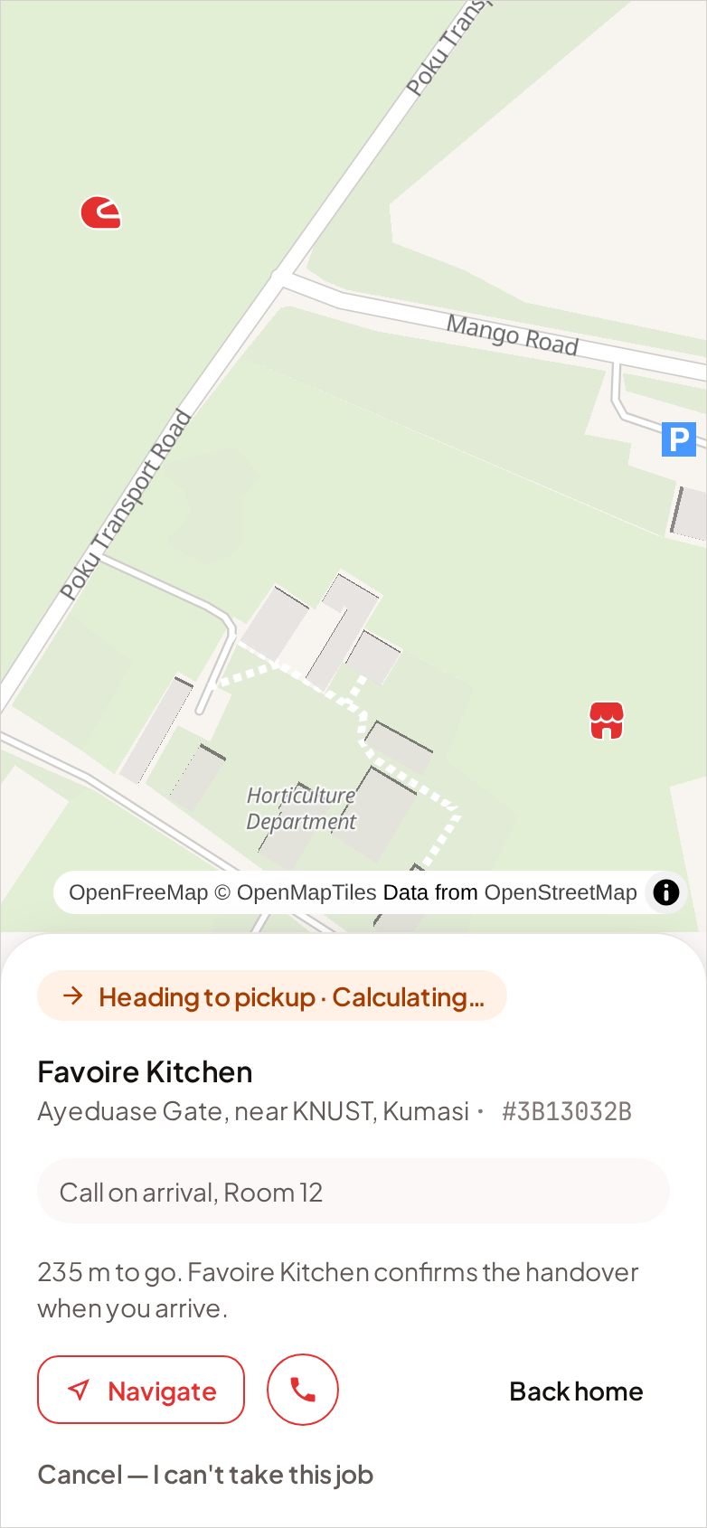
Figure 13. Left: the Orders screen with nothing waiting. Right: the pickup screen after accepting, showing the route to the business.

4.5 Collecting the parcel
Accepting takes you to the pickup screen. It shows the business, its address, the route there, and a call button if you need to reach them.
You do not have to tell YADA you have arrived. When your own position shows you at the shop, the business's screen updates by itself and a Confirm pickup button appears on their side. The badge on your screen changes from Heading to pickup to Parcel collected once they confirm the handover.
- Ride to the business.
- Collect the parcel. Wait for the business to confirm the handover on their screen.
- Select Start delivery.
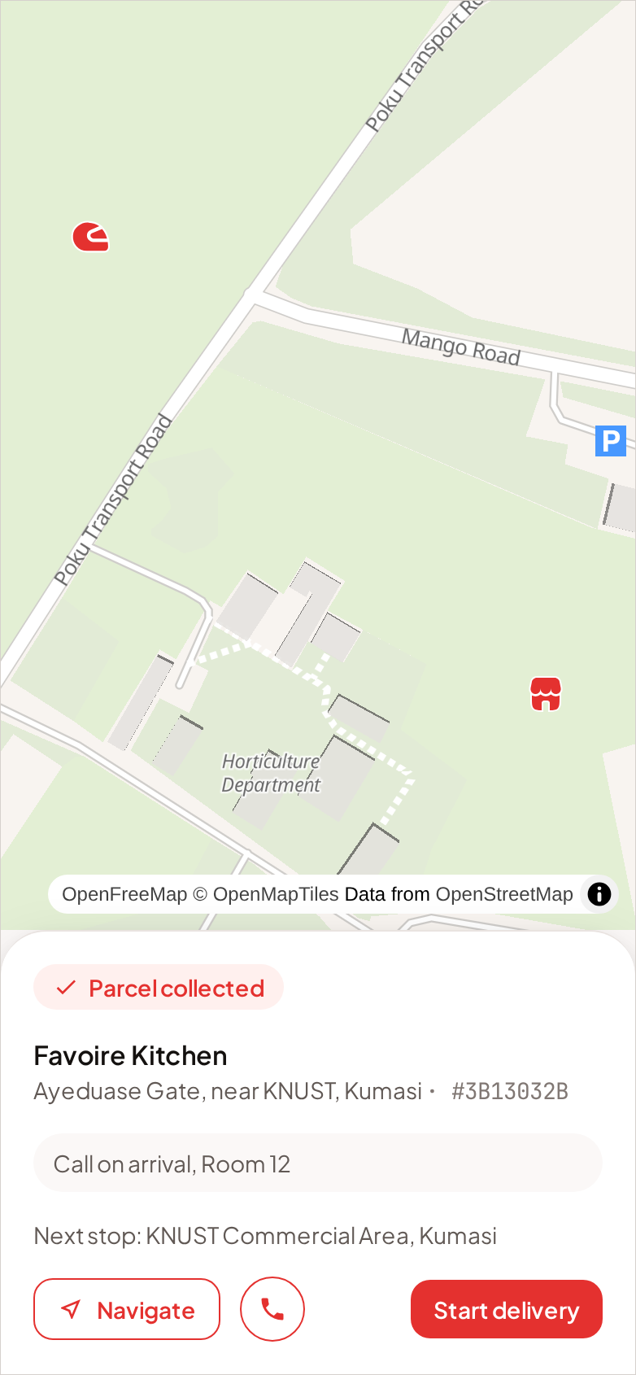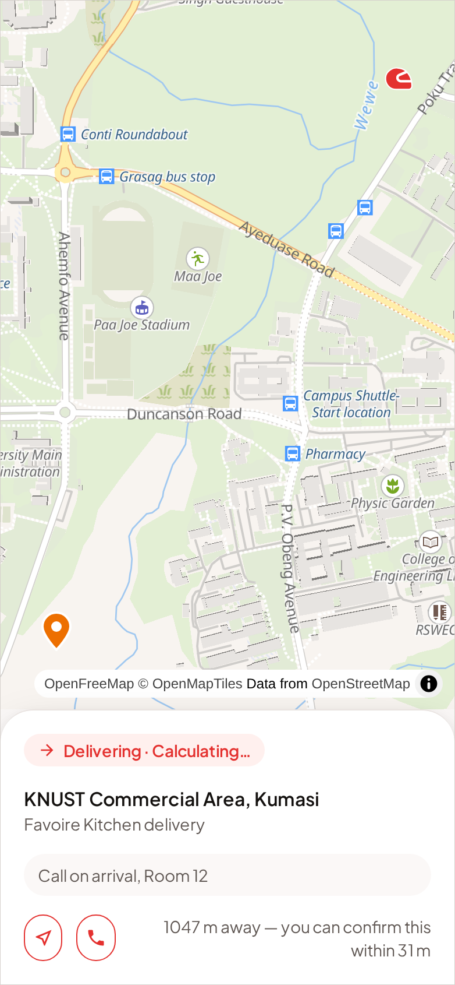
Figure 14. Left: the parcel collected, waiting for Start delivery. Right: the delivery leg, with the route to the customer.

If you cannot take the job after all, Cancel — I can't take this job hands it back. The delivery returns to the board for another rider rather than being cancelled, because the business still needs their parcel moved. Use it as early as you can.

4.6 Delivering
The delivery screen holds the drop-off address, the route to it and a navigation button that opens the address in your maps application. The business can be called from here too.
When you reach the customer and hand the parcel over, select Mark delivered. The button works only when your position is at the drop-off, so a delivery cannot be closed from the road.
IMPORTANT If Mark delivered will not respond, you are not close enough to the drop-off, or your phone has not sent a fresh position. Check that location is still allowed for YADA in your browser, and that you are at the address rather than at the end of the street.

4.7 Finishing, and rating the business
Completing a delivery opens a summary: the distance, the time it took, who it was for and what the order was. You are then asked to rate the business from one to five stars, with an optional note.
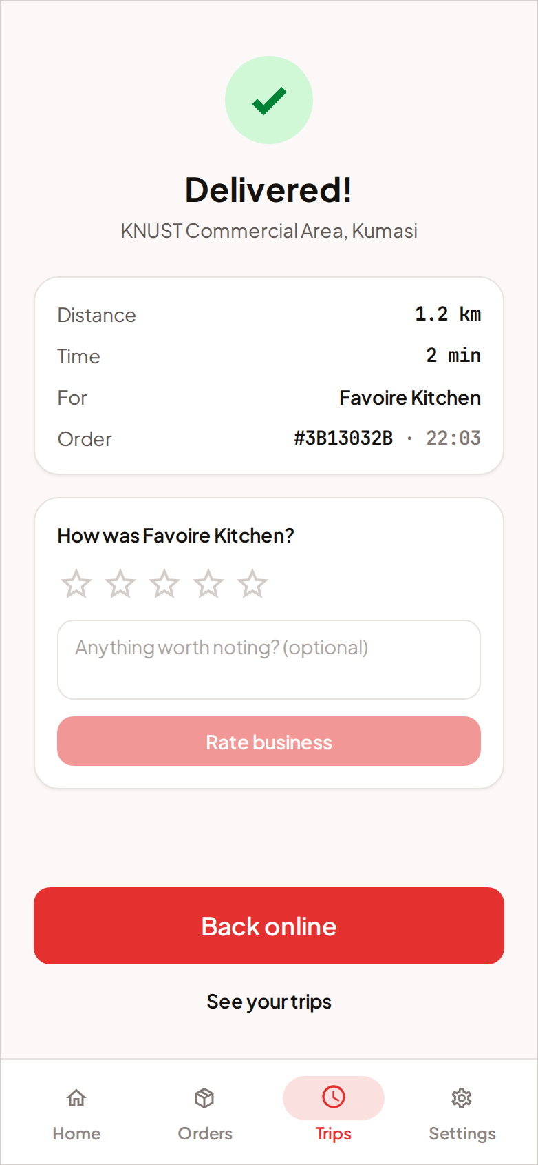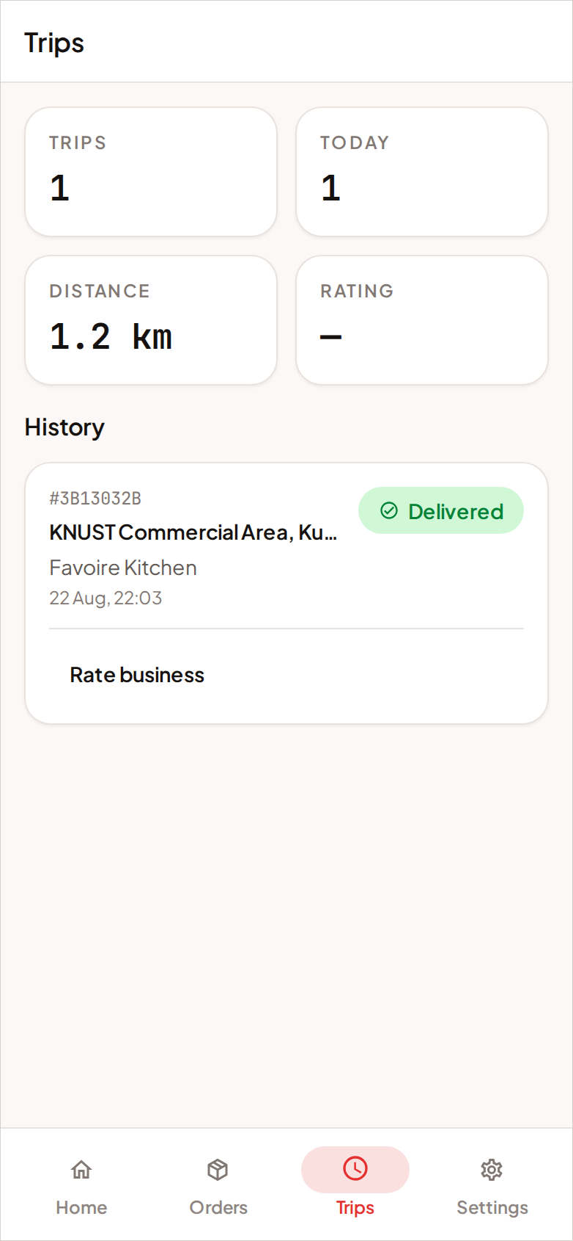
Figure 15. Left: the completion summary and rating prompt. Right: Trips, with the running totals at the top.

Back online returns you to Home, ready for the next request. View trips takes you to your history instead.

4.8 Taking a second delivery on the back of the first
You keep hearing offers while you are carrying a parcel, but only the ones that make sense: a request is offered to a busy rider only when its pickup is within about 400 metres of where the delivery you are on ends. A rider finishing on one street can take the next job on the same street instead of going idle and starting again.
NOTE Riders who are free keep priority. A busy rider's alert opens a few seconds after a free rider's, so chaining a second job never costs an idle rider the work.

4.9 Trips
Trips is your record. Four figures across the top:
Table 10. The Trips summary.
FIGURE | MEANING
Trips | Deliveries you have completed, in total.
Today | Deliveries you have completed since midnight.
Distance | How far you have carried parcels, in total.
Rating | The average rating businesses have given you.

Below them is every trip you have run, newest first. If you did not rate a business at the time, you can still do it from here.

4.10 Settings
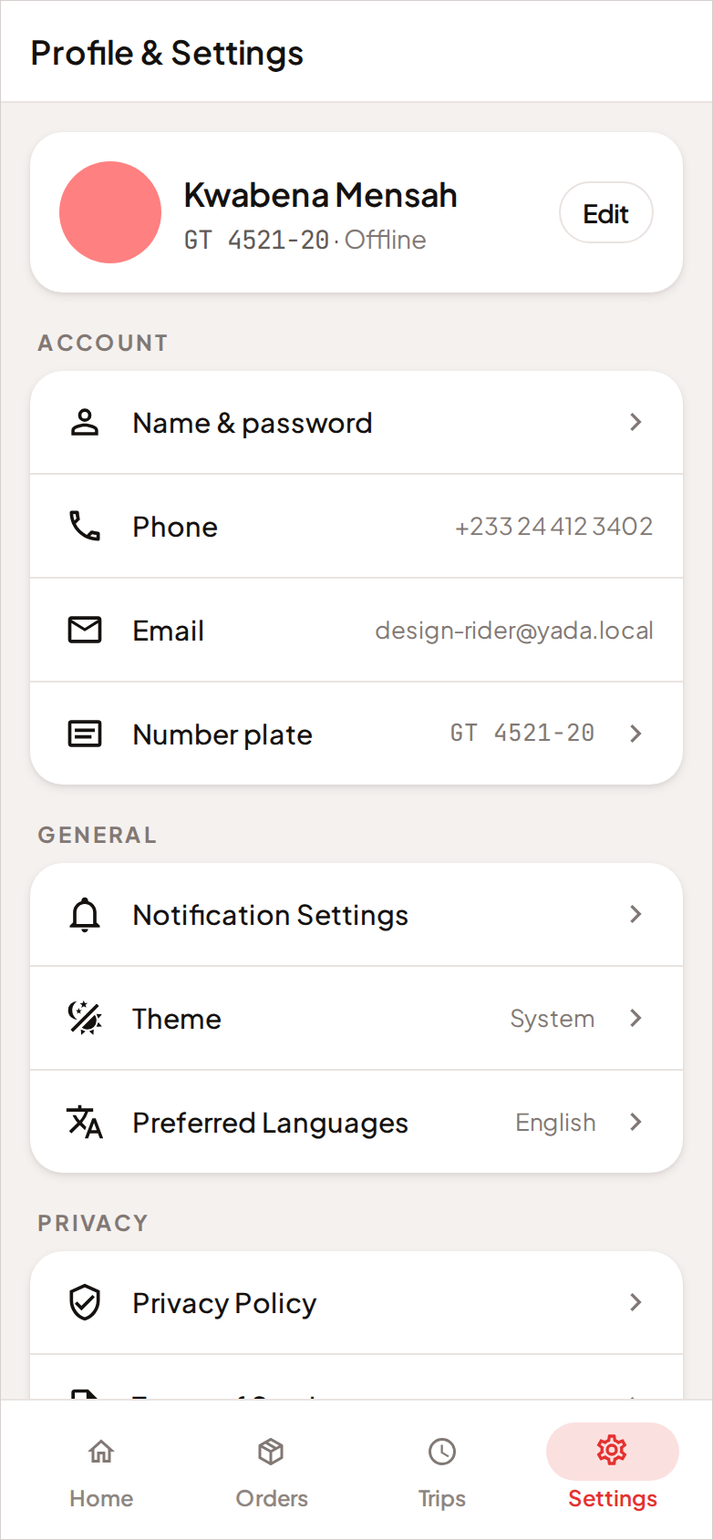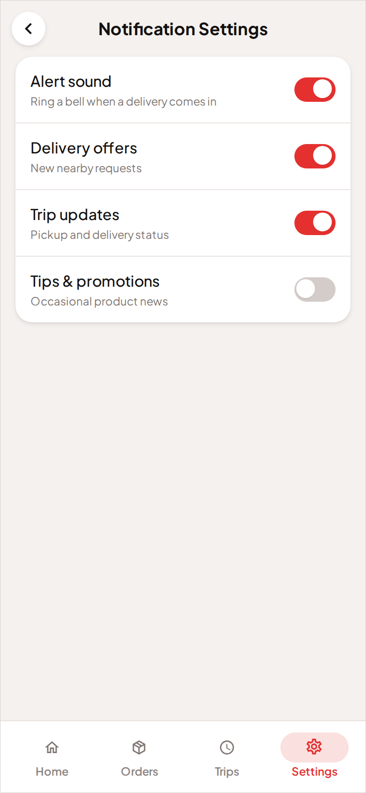
Figure 16. Left: Profile & Settings. Right: the notification settings, including the alert sound.

Table 11. The courier settings rows.
ROW | WHAT IT DOES
Name & password | Change your display name and your password.
Phone | Change the number businesses reach you on.
Email | The address on your account.
Number plate | Change the plate businesses look for at the counter.
Notification Settings | Turn the alert sound on or off, and choose which alerts you want.
Theme | Light, dark, or follow the device.
Preferred Languages | Your language preference.
Privacy Policy / Terms of Service | The legal pages.
Feedback / About Us | Send feedback, and read about the product.
Sign out | Ends the session on this device.

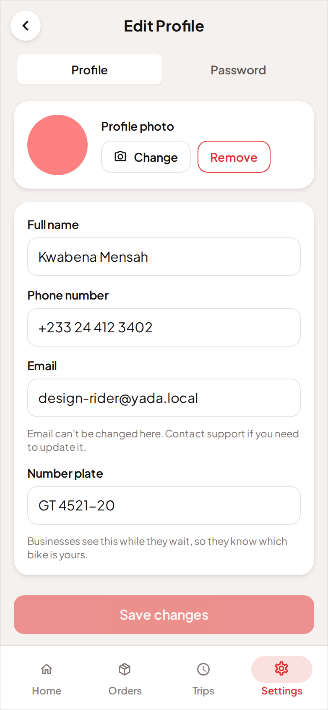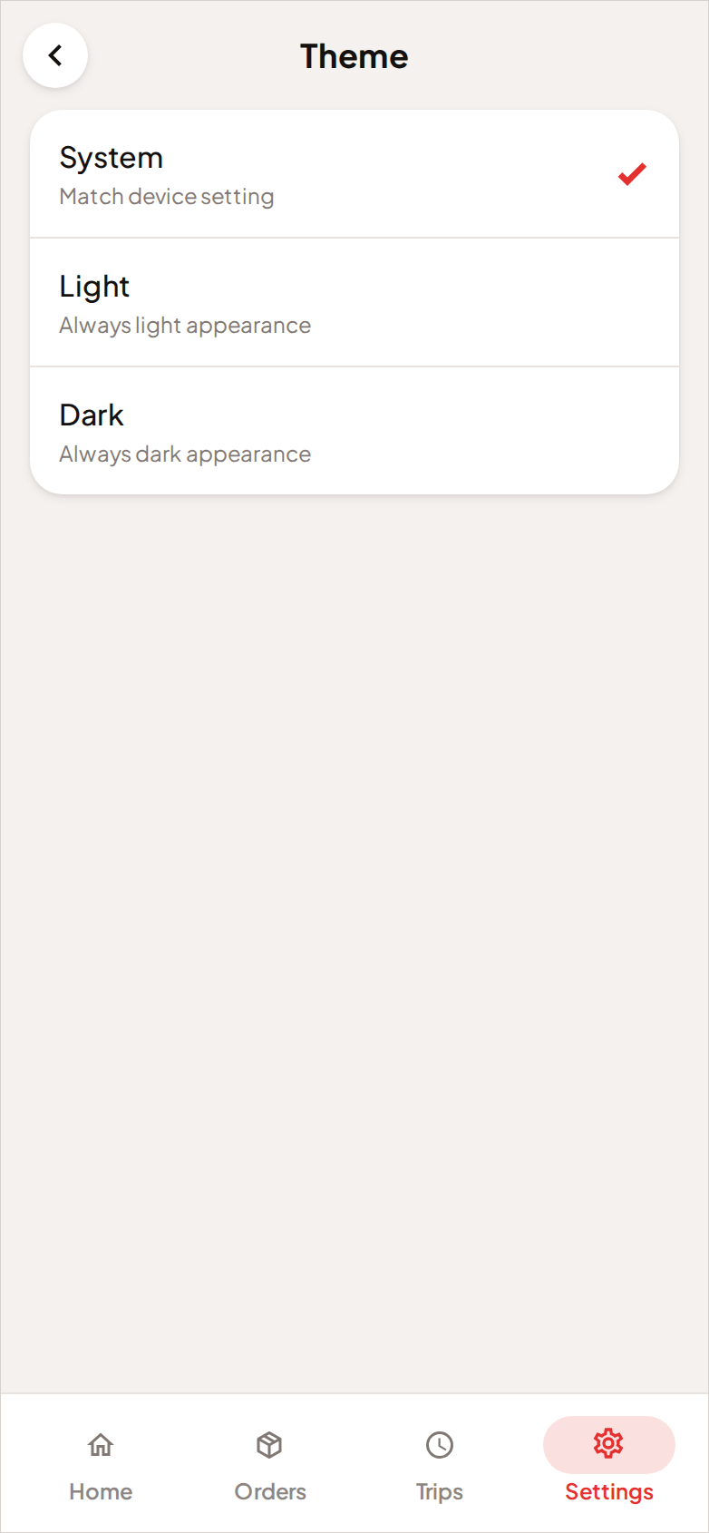
Figure 17. Left: editing your courier profile. Right: the theme picker.

IMPORTANT Alert sound is the one setting worth checking before your first shift. YADA makes the alert tone in the browser itself, and phones silence browser audio in various ways. Test it somewhere quiet before you rely on hearing an offer arrive.

5 How dispatch works
This chapter explains what happens between a business selecting Request a rider and a courier's phone sounding. You do not need any of it to use YADA, but it answers most of the questions both sides ask in their first week.

5.1 The search widens on its own
A request does not go out to everybody at once. It starts with the riders closest to the counter and widens from there, on a fixed clock.
Table 12. The expanding rings of a dispatch search.
TIME SINCE THE REQUEST | RIDERS BEING RUNG | WHAT THE BUSINESS SEES
0 – 15 seconds | Within 400 m of the pickup | The first, tightest ring on the map.
15 – 35 seconds | Within 800 m | The ring widens.
35 – 60 seconds | The whole service area, up to 6 km | The ring widens again.
After 60 seconds | Nobody | The search has ended. Ring riders again appears.

If the 60 seconds pass with nobody accepting, the request returns to the business rather than being silently dropped. Nothing is lost; it simply waits for a decision.

5.2 Who hears about a delivery first
Within a ring, riders are not all alerted at the same instant. Each rider's offer opens a moment decided by three things:
- How near they are. Nearer riders hear first.
- Whether they are already carrying a parcel. A free rider hears a few seconds before a busy one.
- Their rating. A higher-rated rider hears slightly earlier than a lower-rated one in the same ring.
Nobody is excluded outright. A rider who is further away, or busy, or newly signed up, still gets the offer — a little later. New riders are neither given the top of the board nor buried beneath it: an account with no ratings yet is treated as average until it has a record of its own.

5.3 A decline is remembered
When a rider declines a delivery, or lets the offer time out, that decision sticks to that delivery. If the business rings riders again, that rider is not asked a second time. Declining costs you nothing, and it does not affect your rating or your standing.

5.4 When two riders accept at once
Because several riders are rung for the same request simultaneously, two riders tapping Accept at the same moment is normal rather than exceptional. YADA settles it the only way that is safe: the first tap to reach the server takes the job, and the second is told immediately that it has gone. A delivery is never assigned twice.

6 Reference

6.1 Delivery statuses
A delivery moves through a fixed sequence of stages. Both sides see the same stage at the same time, in the words appropriate to their screen.
Table 13. Delivery stages, and what advances each one.
STAGE | WHAT IT MEANS | WHAT MOVES IT ON
Searching | The request has been raised and riders are being rung. | A rider accepts — or 60 seconds pass with nobody.
Assigned | A rider has taken the job and is on the way to the pickup. | The rider's own position shows them at the counter.
Arriving / at the counter | The rider is at the business. | The business confirms the handover.
In progress | The parcel is with the rider, on the way to the customer. | The rider marks it delivered at the drop-off.
Delivered | The delivery is complete. | Nothing. Both sides may still rate it.
Cancelled | The delivery was called off before the handover. | Nothing.

NOTE Arrival at the pickup is observed, not declared. Neither app asks the rider to press “I have arrived” — their own position fix does it. That is why the business's Confirm pickup button can appear without the rider touching anything.

6.2 Ratings
Both sides rate each other, once, after the delivery is complete.
Table 14. How the two ratings are used.
RATING | WHO GIVES IT | WHAT IT AFFECTS
Rider rating | The business, after delivery | How early that rider hears about future requests.
Business rating | The rider, after delivery | Nothing in dispatch. It is informational — businesses are not ranked for a job the way riders are.

A rating can be given later from History (business) or Trips (courier) if you skipped it at the time.

6.3 Distances and timings
These are the numbers the system works to. They are listed here because both sides occasionally need to know why a button has not appeared yet.
Table 15. System distances and timings.
SETTING | VALUE | WHERE IT MATTERS
First ring | 400 m | Who is rung in the first 15 seconds of a search.
Second ring | 800 m | Who is rung from 15 to 35 seconds.
Match radius | 6 km | The widest a search ever goes.
Search window | 60 seconds | How long a request rings before it returns to the business.
Pickup proximity | About 15 m | How close a rider must be for Confirm pickup to appear on the business's screen.
Drop-off proximity | About 31 m | How close a rider must be for Mark delivered to work.
Chaining distance | 400 m | How near a new pickup must be to your current drop-off for you to be offered it while busy.
Nearby riders | About 10 minutes' ride | The area the rider count on the Request screen covers.
Position reporting | Every 10 s idle, every 2.5 s on a trip | How often a courier's position is sent while online.

7 Privacy, safety and your data

7.1 What each side can see
Table 16. Who sees what.
INFORMATION | BUSINESS SEES | COURIER SEES
Business name, photo and address | Own | Yes, once assigned
Rider name, photo, plate and rating | Yes, once assigned | Own
Phone number of the other side | Yes, during the delivery | Yes, during the delivery
Destination address | Yes | Yes
Order name | Yes | Yes
Order value | Yes | No — never
Rider positions before booking | Anonymous markers only | n/a

IMPORTANT A courier is never shown what an order is worth. A rider carries the parcel either way, and a value on their screen is a reason for somebody to take it from them. The field exists so a disputed handover has a number attached to it, and it stays on the business side.

The riders a business sees on the map before booking are anonymous by construction. There are no names, no ratings and no identities behind those markers, and each position is rounded to roughly eleven metres. The map shows how much supply is nearby, not who is nearby.

7.2 Location reporting
A courier's position is reported only in the situations that need it.
- Only while you are online, or on a trip. Go offline and reporting stops.
- At two rates. Roughly every ten seconds while you are waiting, and every two and a half seconds while you are carrying a delivery, so the business's map keeps up with you.
- To the delivery you are on. A business sees the position of the rider carrying their parcel, and no one else's.
Businesses do not report a position at all. Their location is the fixed dispatch address they set once.

7.3 Closing your account
You can close your own account, from Account → Delete account on the business side, or from Settings on the courier side. You will be asked to type your email address to confirm.
Closing an account:
- Removes your credentials, your sessions, your email address, your phone number and your photo, and signs you out everywhere.
- Keeps your name on past deliveries, so the other side of each one keeps their own history and their ratings.
- Is refused while a delivery of yours is still in flight. Finish or cancel it first.
IMPORTANT Closing an account cannot be undone. There is no restore.

8 Troubleshooting
Table 17. Common problems and their remedies.
PROBLEM | LIKELY CAUSE | WHAT TO DO
I signed in but cannot send a delivery or go online. | Your email address is not verified yet. | Open the verification email and select the link. Check the spam folder, then resend from the banner in your workspace.
Go online does nothing, or asks about location. | The browser has not been given location permission. | Allow location for the YADA site in your browser settings, then try again.
I am online but receive no requests. | No business near you has raised one, or you are outside the service area. | Stay online and within the KNUST / Ayeduase area. Requests only reach riders within 6 km of a pickup.
I did not hear the alert for an offer. | The alert sound is off, or the phone silenced browser audio. | Check Settings → Notification Settings → Alert sound, and test it somewhere quiet before a shift.
The search ended without finding a rider. | Nobody online was near enough, or everybody near enough declined. | Select Ring riders again. Riders who declined are not asked twice, so a repeat search reaches different people.
Confirm pickup has not appeared. | The rider is not close enough to your counter yet, or their last position is stale. | Wait for them to arrive. If they are standing in front of you and it still has not appeared, ask them to check their phone has location on.
Mark delivered will not respond. | You are not close enough to the drop-off address. | Move to the address itself rather than the end of the street, and check location is still allowed for YADA.
A job disappeared while I was reading it. | Another rider accepted it first. | Nothing to do. Several riders are offered the same request at once, and this counts against you in no way.
The map is empty or will not load. | A connection problem, or the mapping service is unavailable. | Check your connection and reload. Addresses and landmark names still work when the map does not.
I cannot cancel a delivery. | The rider has already reached the counter. | From that point it is a conversation rather than a button. Call the rider — the call button is on the tracking screen.
I chose the wrong role at sign-up. | The role is set once and cannot be changed. | Close the account and sign up again with the correct role.
A reset link says it does not work. | The link has already been used, or it has expired. | Request a new one from Forgot password on the sign-in screen.

9 Glossary
Table 18. Glossary of terms.
TERM | MEANING
Business | An account that raises delivery requests. One of the two roles in YADA.
Courier / rider | An account that accepts and carries out deliveries. The other role. The two words are used interchangeably in this manual and in the application.
Delivery request | One parcel, going from a business's dispatch address to one destination.
Dispatch | The process of finding a rider for a request: who is rung, in what order, and for how long.
Dispatch address | The fixed pickup point every one of a business's deliveries leaves from.
Drop-off | The destination of a delivery.
Handover | The moment the parcel passes from the business to the rider. Confirmed by the business.
Offer | A request presented to one rider, with a countdown, to accept or decline.
Pickup | The business end of a delivery.
Ring | The distance a search currently covers. A search moves through three rings before it times out.
Release | A rider handing back a job they had accepted, so it returns to the board for someone else.
Service area | The KNUST and Ayeduase area of Kumasi, within which YADA matches deliveries.
Workspace | The set of screens belonging to one role. There is a business workspace and a courier workspace, and an account only ever sees one.

End of document.

